Feedback on the application SLI Markup: Create service level indicators in Azure Monitor - Azure Monitor | Microsoft Learn

Section Create SLI
There is redundancy between point# 4 and the text below the image. Correction: Keep points 1,2,3. Then show this image .
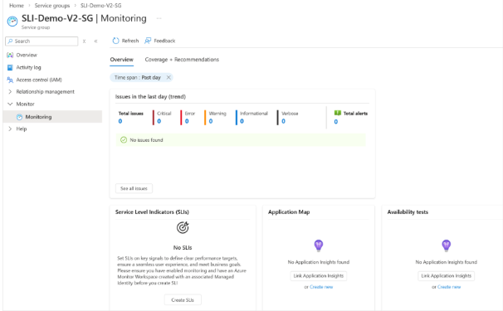
- After the image continue with the text: The Create SLIs action opens the Basics tab, where you choose the indicator type and provide identifying details for the new SLI.
- Then add the three bullets from top:
- On the Basics tab, select the SLI type.
- Choose a SLI Type:
- Choose Availability when you want to measure whether requests or time windows meet a success condition.
- Choose Latency when you want to measure whether requests or time windows stay within a latency threshold.
- Enter a name and description for the SLI.
- Select Next.
Paste the image below: 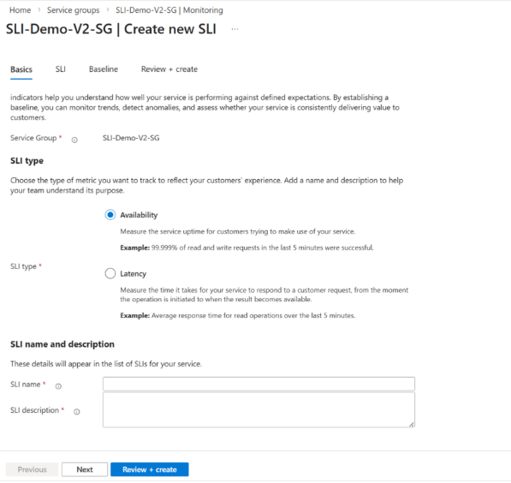

Remove the text below this image “Choose Availability when you want to measure whether requests or time windows meet a success condition. Choose Latency when you want to measure whether requests or time windows stay within a latency threshold.” Since we have already added it above.
Section: Configure a request based SLI
- Pull the first image with good and total signals just below the two bullet points for good and Total signal.
like this: Request-based SLIs require two signals:
A good signal that represents successful requests.
A total signal that represents all eligible requests.
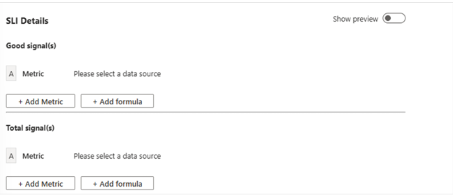
- Paste the below bullets (from initial placement) after the image :
- Under Good Signal, select the metric that represents successful requests.
- Add any dimensions, filters, and temporal aggregations that are required for the metric.
- If needed, add a spatial aggregation to combine multiple time series after temporal aggregation.
- Add Note: then the text "After the signal sections are available, add the metric logic, filters, and any formulas that combine multiple metrics into the numerator or denominator”
- Repeat the process under Total Signal to select the metric that represents all requests.
- If either signal requires multiple metrics, use Formula to combine them.
- Select Show Preview charts to confirm that the query returns the expected results.

- Section Set the baseline section
- Rename to "Baseline + Alerts" . Insert the text- Once the baseline is set, you can choose to use this baseline target for alerting. Azure SLIs provide three types of alert:
- Baseline based- based on the static threshold entered
- Burn rate based (Which are further divided as Slow and Fast).
Use this image:
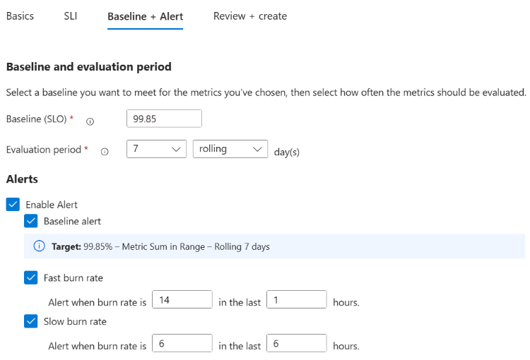

- Section View and Manage SLIs -
- Pull the bullets 3 and 4 below the 1st image of View all SLIs. So:
- Open the service group, and then select Monitoring.
- To view all SLIs for the service group, open the SLI management page.

Use this image (earlier one had a bad SG name) :
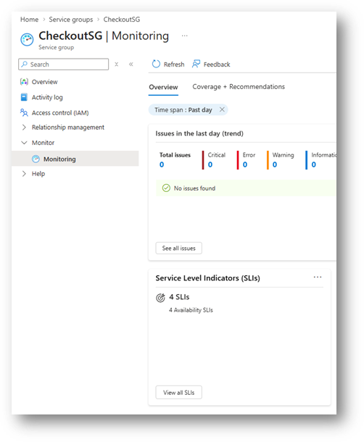
- Then add the View all SLI text below this: Select View all SLIs to open the management experience, where you can compare each definition and review its current compliance state.
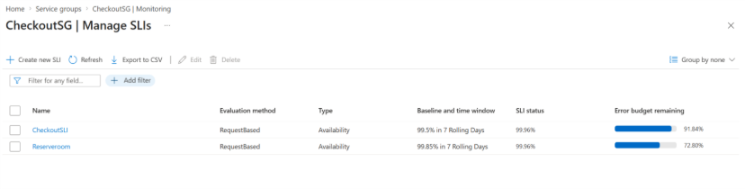
- Then insert the earlier two bullets : 3 and 4 down to the second image. So:
- Select an SLI to view its trend, error budget, and burn rate charts.
- Edit or delete the SLI if you need to adjust the definition.

We also need additional page for guides or how to-do:
How is SLI calculated?
Service Level Indicator (SLI)
A Service Level Indicator (SLI) represents the proportion of successful events relative to the total number of events over a defined time window. In this context, successful events are those that meet a predefined user-experience condition, while the total includes all observed events during the measurement period.
Error Budget
When you define an SLO target (for example, 99.9% availability), the error budget represents the allowable margin of failure within that objective. It is calculated as:
Error Budget = 100% − SLO Target
This value reflects the maximum acceptable level of unreliability permitted while still meeting your service objective.
Burn Rate
Burn rate is a unitless metric that indicates how quickly your error budget is being consumed compared to the intended pace defined by your SLO. Burn rate alerts evaluate the recent error rate—the ratio of observed failures to the expected allowable failures over a specific time period—to determine whether the service is degrading faster than planned.
You can also interpret burn rate as a multiplier of your ideal error rate. For example, for a 99.95% baseline(SLO) measured over 30 days, a burn rate of 6 means the service is consuming its error budget six times faster than expected.

